# Project Design Phase-I Solution Architecture

|  |  |
| --- | --- |
| Date | 19 September 2022 |
| Team ID | PNT2022TMID29836 |
| Project Name | CUSTOMER CARE REGISTRY |
| Maximum Marks | 4 Marks |

**Solution Architecture:**

* **A portal for admin is created in which the admin assigns the complaint tickets to the workers.**
* **An admin can be able to add or remove a worker.**
* **A customer login/sign up portal will be given in which He/she is able to login/ sign up and raise the tickets.**
* **The web application contains a Watson Assistant which guides the customers with suitable information.**
* **The chatbot will be able to provide answers for the Frequently asked Questions (FAQ).**
* **After the complaint ticket is raised by the customer, the admin assigns the tickets to individual workers.**
* **The customer and the worker will communicate through mail or by direct calls.**
* **By this, each and every complaint will be taken care of.**

# Solution Architecture Diagram:

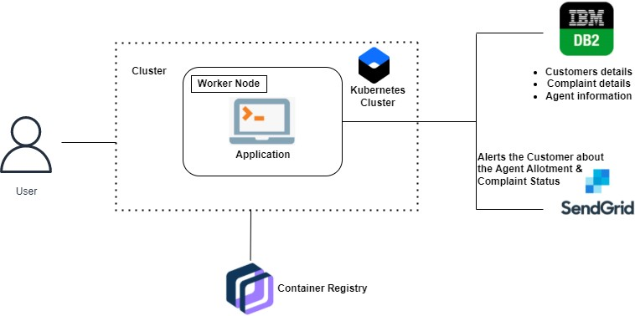

*Figure 1: Architecture and data flow of the Customer Care Registry application*